DATABASE SYSTEMS ENGINEERING AND DISTRIBUTED BACKEND DEVELOPMENT

TOPIC: AGGREGATE FUNCTIONS with WHERE , GROUP BY, HAVING, ORDER BY

2520030413 – CH. KAVYA SREE
STEP 1: CREATE TABLE:

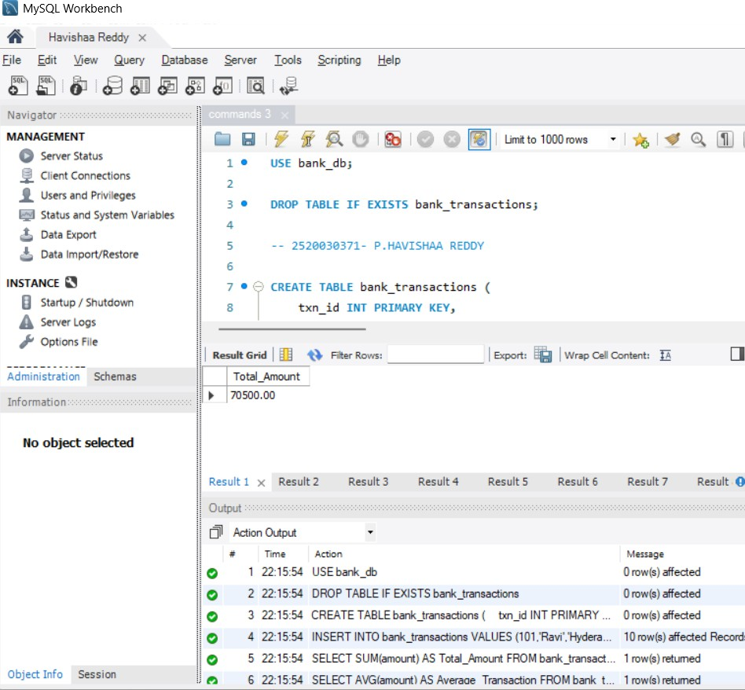

QUESTION 1 – SUM ():

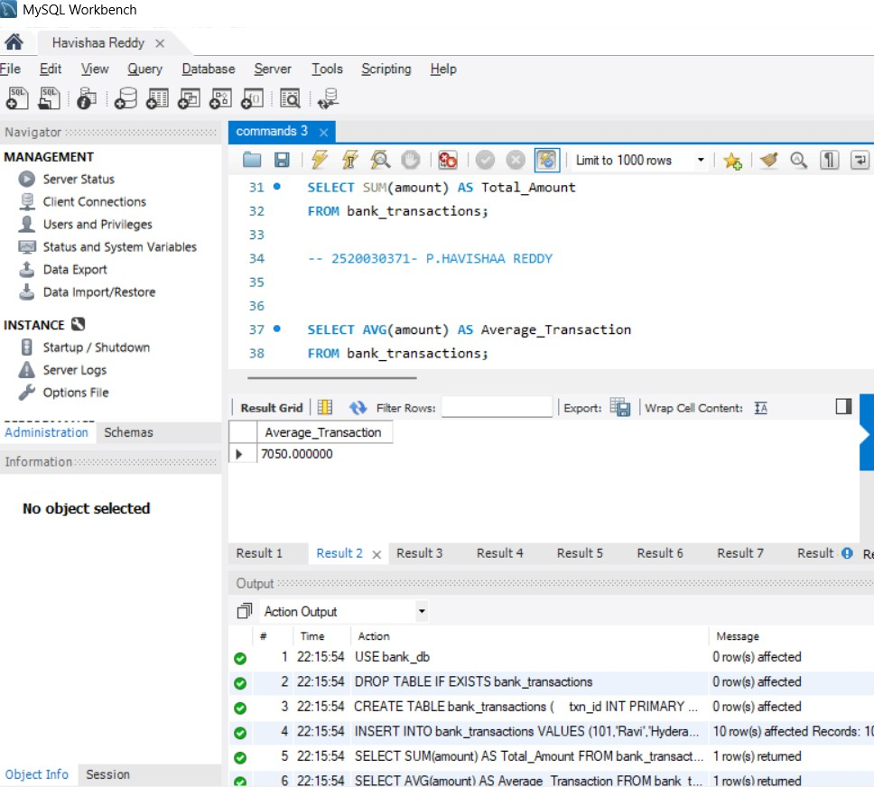

QUESTION 2 – AVG ():

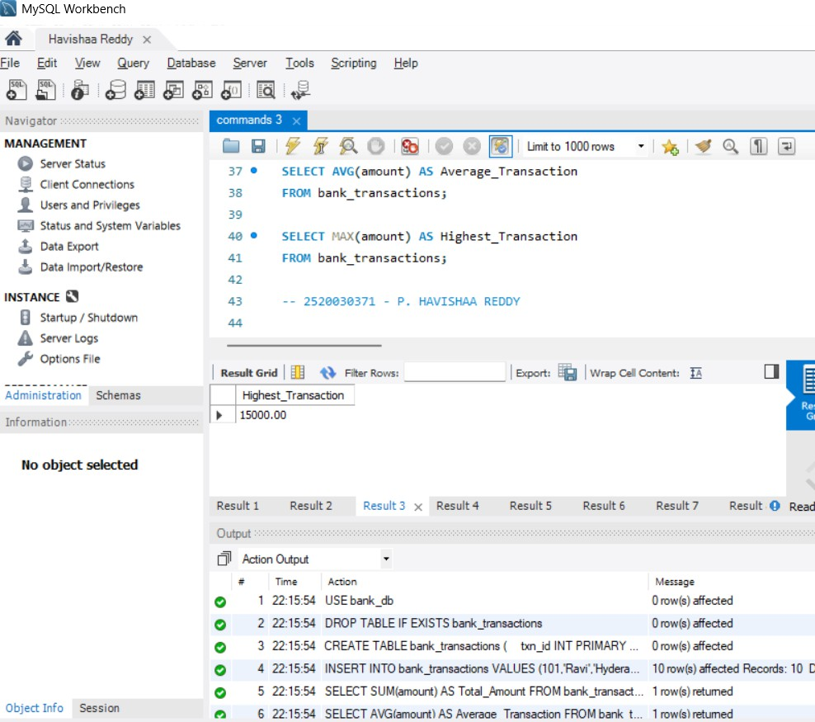

QUESTION 3 – MAX ()

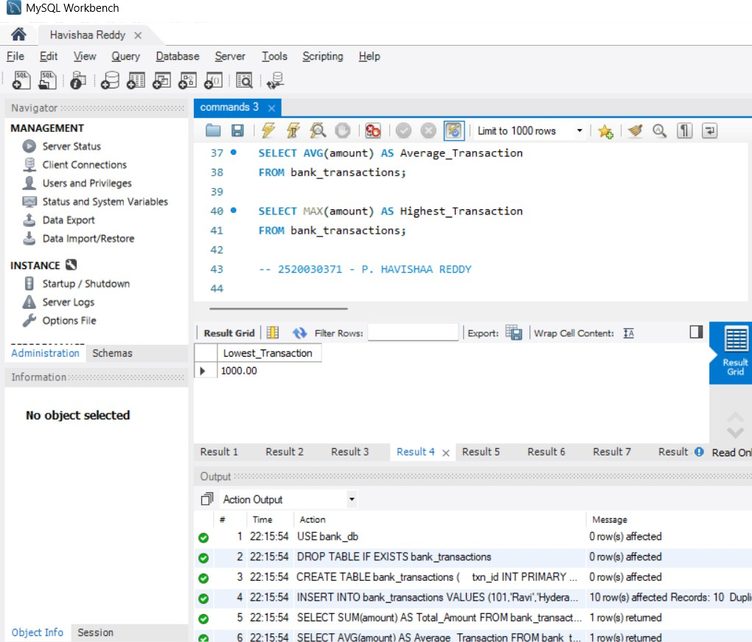

QUESTION 4 – MIN ()

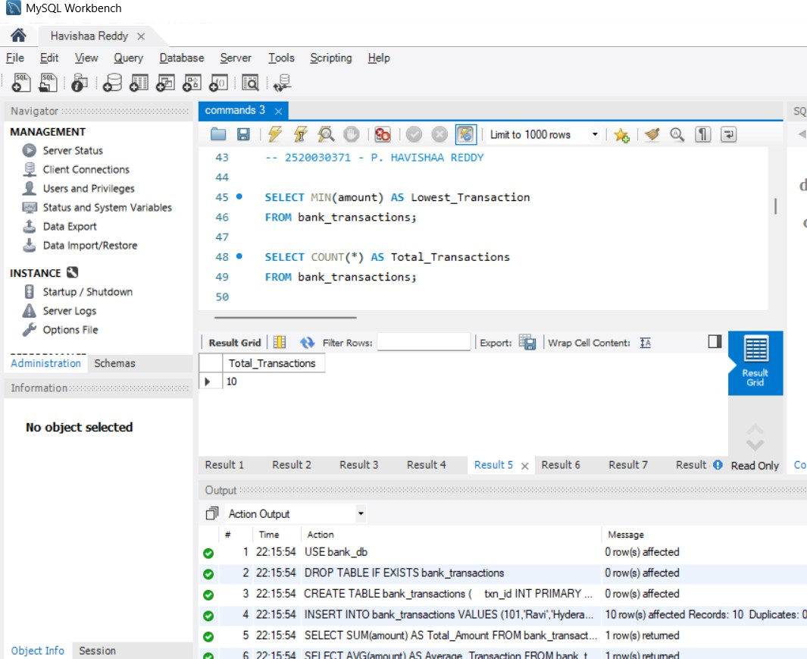

QUESTION 5 – COUNT ()

